About the Phone Number Python project.

For this project, we have used Python programming and a library namely phonenumbers. So, first of all go to your terminal, and write this command over there-



After this, open up your IDE. For this Project we will use Sublime Text Editor.

So, let’s start downloading it-

• Go to <https://www.sublimetext.com/3>. There you will see this screen-

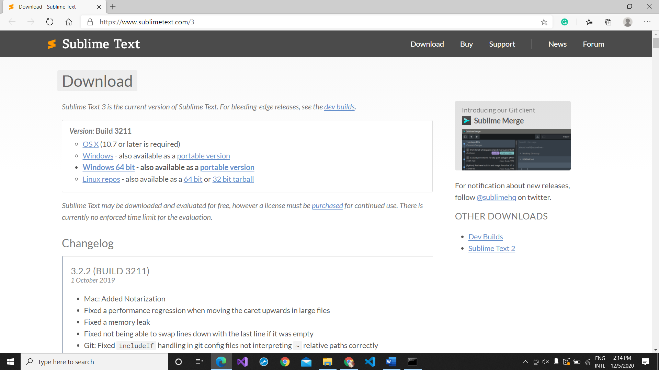

-I have a windows laptop containing 64-bit. If you have any 16 bit or 32 bit’s windows than don’t download this one. You click on windows button which is just over the Windows 64-bit.

-After clicking on your desired OS stuff, it will start downloading your Sublime Text 3.

-And just open up the setup.

-It will ask something as-

**Do you want this app to make changes to your device?**

-Click on Yes for that question.

-Your setup will be opened-

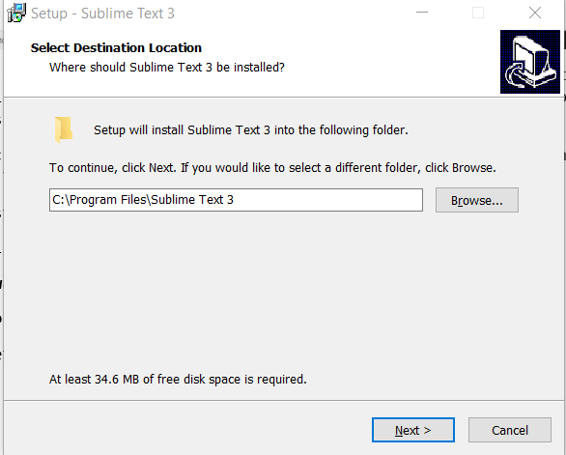

-Click on **Next >** or just set your desired path location by clicking on that **Browse** button and then click on **Next >**.

-Another box will come, asking this question-

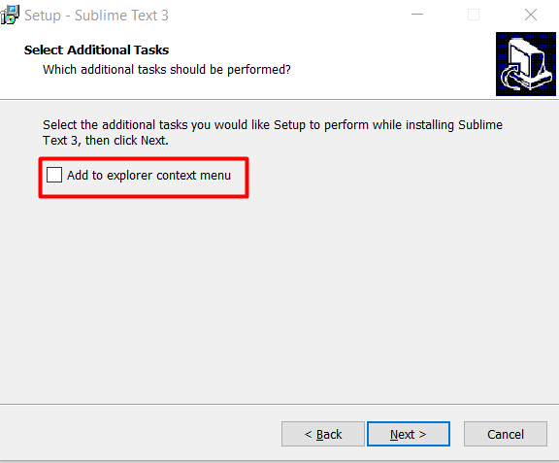.

-Check that checkbox and click on **Next >**.

-Now it will show you some utilities like this-

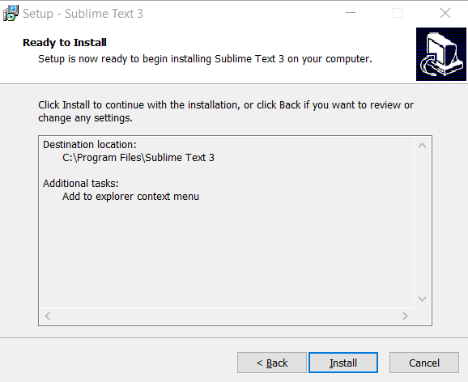.

-Click on **Install** button which will appear on the screen.

-It will show another screen after installing which looks like this-

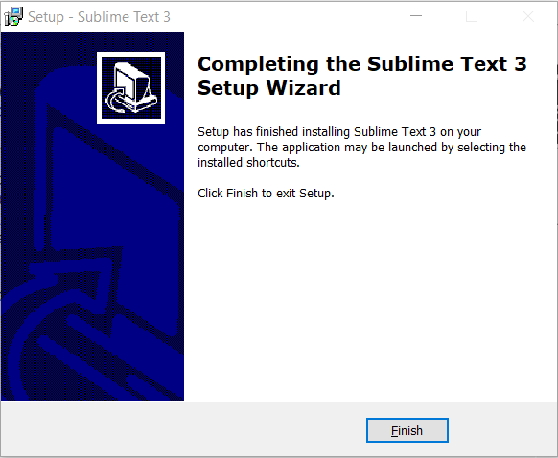.

-Click on that finish button.

-Open up your sublime text 3 and the file explorer.

-And make a folder in desktop and drag and drop it to your sublime text 3.

-After doing the same, you will see this screen-

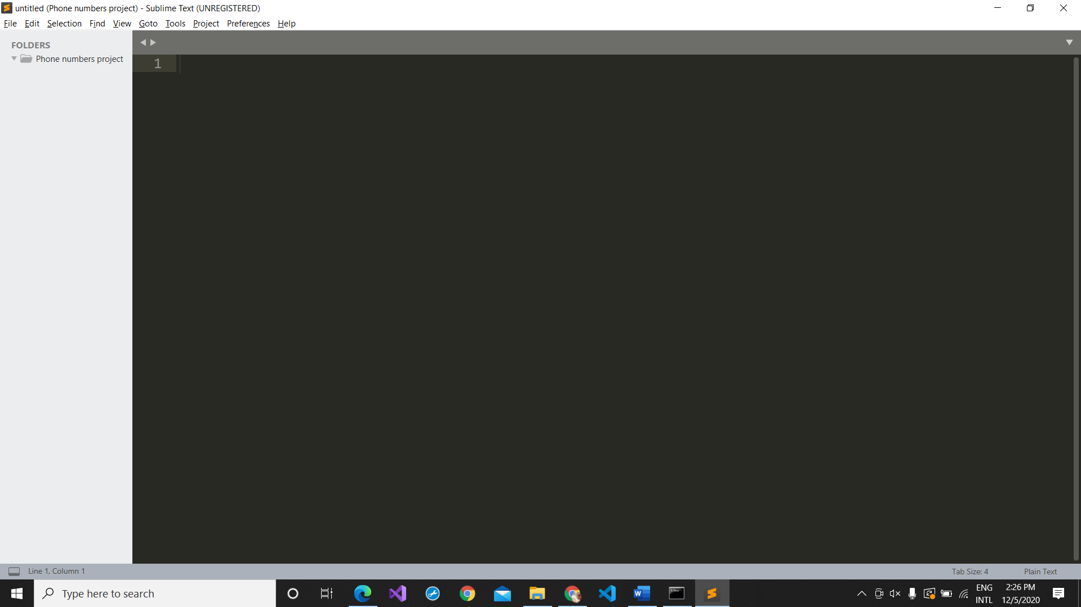

-**Phone numbers project** is my folder name-

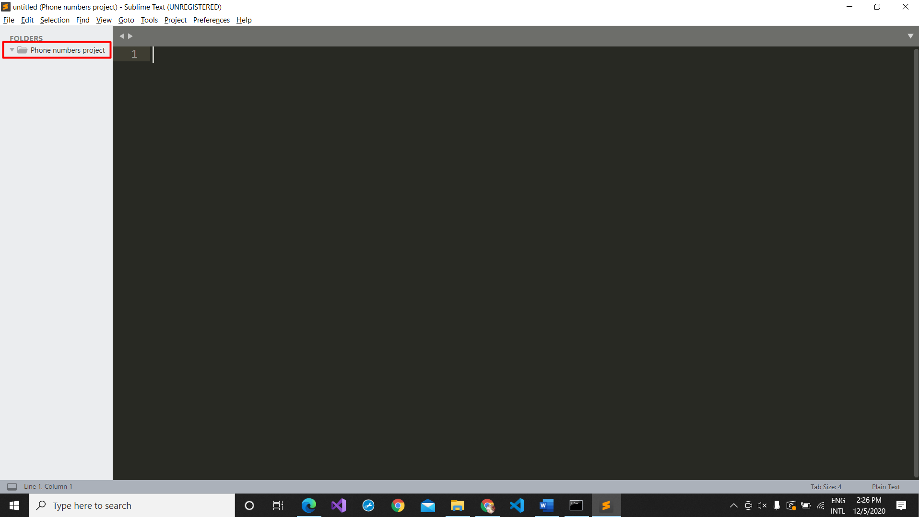

-Right click on that-

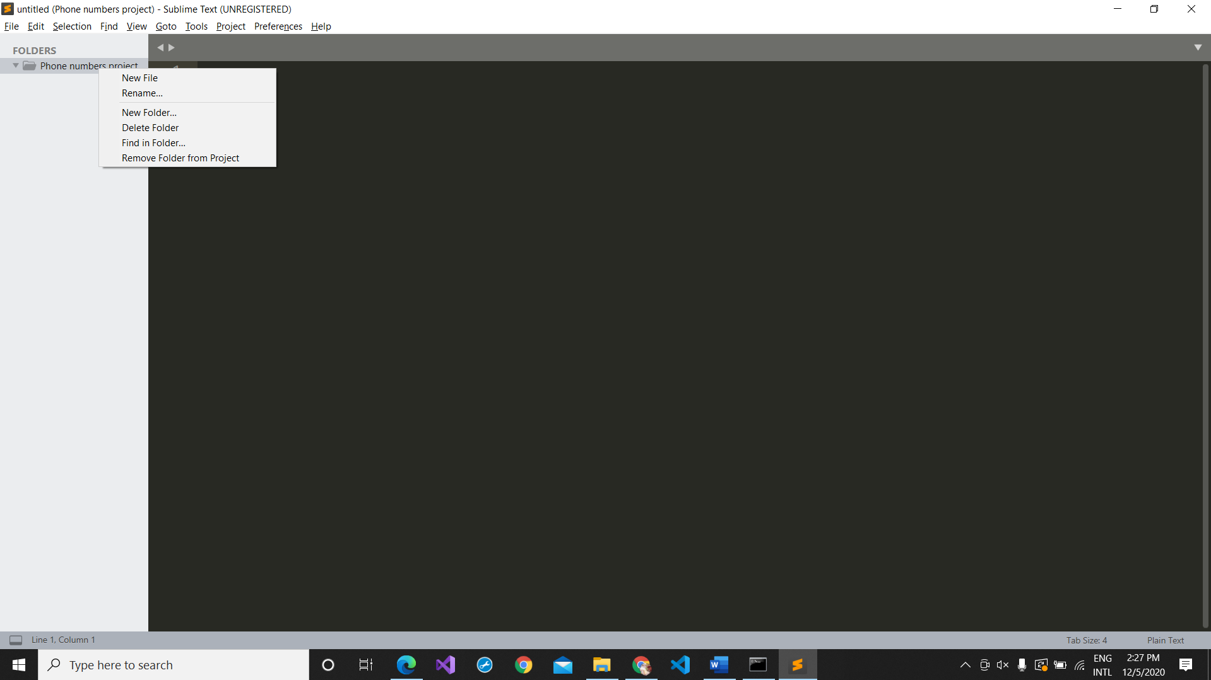

-Click on **New file** on the select list.

-Save it as **main.py** after turning it to **All files (*.*)**

-Don’t worry, after naming it just click on **Enter** key because it will save the file there only.

-And now write there –

.

-And again, make a new file namely **numbers.py.**

-And write this there-

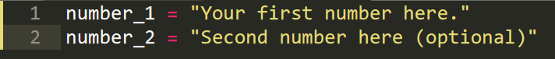

(Instead of that **Your first number here** and **Second number here (optional)**, we have to write any number with the country code.)

-Go to your **main.py** and write this there-



(Here I have took my **number.py** file and imported the two variables namely **number_1** and **number_2** which I have made within that file.)

-And now in the next line, write these words there-



(It means that from the phonenumbers library I will import a module namely geocoder.)

-In the next line write this code there-



(This means that I have made a variable namely **ch_number** in which I have configured the **phonenumbers** library and a module from it namely **parse.**)

-And now in the next line write this code-



(In this line, we have configured the **ch_number** variable into the **defining_number** variable.)

-Switch to next line and write this code there to enable the geocoder power machine for the Country name configuration-



-Now we will import another module from the library **phonenumbers** (the module name is carrier)-



-Now, we will track the service provider (like- Airtel, O2) purchased by the person for the phone number-



-And now it's the time to print all the activities which he has done upwards so, we will write this there-



Source code of this project available at-

https://github.com/drmaitrey/projects/tree/main/phone%20number

-------------------------------------------------------DONE-----------------------------------------------------------------------!!!!!!!!!!!!!!!!!!!!!!!!!!!!!!!!!